ALL INDIA STATE BANK OFFICERS’ FEDERATION
(Registered under the Trade Unions Act 1926, Registration No: 727/MDS)
State Bank Buildings, St. Mark’s Road, Bangalore – 560 001

CIRCULAR NO.144 DATE: 05.12.2018

TO ALL OUR AFFILIATES/MEMBERS:

NOTICE OF STRIKE

We reproduce hereunder the text of AIBOC Communication No. 2018/STRIKE NOTICE/01 dated 4th December, 2018 contents of which are self-explicit.
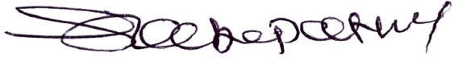

(RAMKUMAR SABAPATHY)
GENERAL SECRETARY
TEXT
QUOTE:
FORM – 1

NAME OF UNION : ALL INDIA BANK OFFICERS’ CONFEDERATION (A.I.B.O.C.)

NAMES OF ELECTED REPRESENTATIVES
- Shri. Sunil Kumar, Chairman, AIBOC
- Shri. Debasis Ghosh, President, AIBOC

- Shri. Soumya Datta, General Secretary, AIBOC

Dated the 4th December, 2018
To
The Chairman
Indian Banks’ Association
World Trade Centre
Cuffe Parade, Mumbai

Sir,

In accordance with the provisions contained in sub-section (1) of Section 22 of the Industrial Dispute Act 1947, we hereby give you notice that the members of All India Bank Officers’ Confederation propose to go on 24 hours CONTINUOUS STRIKE from Midnight of 20th December, 2018 to Midnight of 21st December, 2018 on the following issues:

DEMANDING:

- Full and Complete Mandate for officers (Scale I to VII) wage revision in 11th Bi-partite settlement

- Salary revision as per charter of demands only.

- To ensure proper work-life balance of the bank officers and immediate introduction of 5 day week

- Settlement of retirees issues including family pension/ updating of pension

- Focus on Core Business and NPA Recovery – Stop Mis-selling of Third Party Products

- Scrapping of NPS and switching over to Defined Pension Payment Scheme as existing

- Immediate resolution of HR issues in Catholic Syrian Bank and IDBI Bank

- Parity in Pension and other benefits of RRBs with Public Sector Banks

OPPOSING:

- Fractured Mandate

- The proposed amalgamation of Bank of Baroda, Vijaya Bank and Dena Bank

- The Government move to merge/ amalgamate existing Regional Rural Banks

- Unabated attack on Bankers in various parts of the country while discharging official duties

- Unilateral reduction of medical benefits of officers

- Steep increase in Medical Insurance Premium of Retirees
The details of the programs and the Statement of the Case are enclosed.

Yours sincerely,

Sd/-
(Soumya Datta)
General Secretary

Encl: | 1. | Statement of the Case
 | 2. | Details of Agitational Programme

Copy to:

- Chief Labour Commissioner (Central), New Delhi
- Regional Labour Commissioner, Mumbai
- CMDs/MDs/CEOs of all Banks
- Chief Executive, IBA, Mumbai
- The Secretary, Department of Financial Services, Govt. of India
- The Joint Secretary, DFS for RRBs
- The Chairman, NABARD

Sd/-
(Soumya Datta)
General Secretary

1. STATEMENT OF THE CASE

Whereas Settlement/ Joint Note was signed by the Indian Banks’ Association with the Employees Unions and Officers Organisations in the Banks on 25-05-2015 covering revision of wages and improvements in other service conditions for the period from 1-11-2012 to 31-10-2017 and

Whereas the operation of the said Settlement/ Joint Note was to end by 31-10-2017 and

Whereas the need would arise to revise the emoluments and service conditions with effect from 1-11-2017 and

Whereas the Unions and Associations submitted common Charter of Demands to the Indian Banks Association in February, 2017 and May, 2017 with a plea to the IBA to take up the demands for discussions and early resolution so that the revised pay scales, allowances and service conditions can be implemented from the due date i.e. 1-11-2017 and

Whereas, having regard to the delay in negotiations and finalising the Settlements in the past, as early as 12-1-2016, the Department of Financial Services, Ministry of Finance, Government of India advised all the Banks as well the Indian Banks Association to initiate the process of wage revision and conclude it prior to the effective date i.e. 1-11-2017 and

Whereas having regard to avoid the delay in arriving at a settlement, the Department of Financial Services, Ministry of Finance, Government of India reminded the Banks and IBA several times with their reminder communications to complete the wage revision process without delay and

Whereas the IBA commenced the discussions with the Unions on 2-5-2017 with the assurance that the discussions would be completed by October, 2017 and

Whereas the Negotiating Committee of the IBA held negotiations with the Unions on various dates, the latest being on 30th November 2018 and

Whereas, in every round of negotiations, All India Bank Officers’ Confederation unequivocally demanded that IBA should ensure that all its member banks submit unconditional mandate for facilitating meaningful discussion and

Whereas, despite the fact that the majority of the Banks had already submitted ‘unconditional mandate’, IBA was neither agreeing for any meaningful discussion as per charter of demand and up to scale VII nor was making effort to ensure that the left over banks also submit the ‘unconditional mandate’ and to substantiate their offer, IBA stated that the financial positions of our Banks are not conducive to offer better wage revision and that the Banks profits have been eroded in the recent years.

Whereas there have been several attempts to create a smoke screen to divert attention from the real issues that continue to surround and plague the banks. The core issues are highlighted as below:

Sl. no. | True State of Core Issues
01 | Issue of fractured mandate
02 | Wage Settlement as per charter of demand and Profitability of member banks
03 | Proper Work-Life Balance in Banking Sector
04 | Pension related issue
05 | Issues of Mis-selling of Third party products
06 | Scrapping of NPS and switching over to Defined Pension scheme
07 | Serious HR issues in Catholic Syrian Bank and IDBI Bank Ltd.
08 | Merger/ amalgamation of RRBs, Parity of Pension and other benefits with PSBs
09 | Amalgamation in banking sector
10 | Attack and Assault on Bankers
11 | Unilateral reduction in Medical Benefits of officers
12 | Steep increase in medical insurance premium
- Issue of fractured mandate:

Most of the member banks have already given unconditional mandate to IBA. This has been the practice since 1979 when the uniform regulations on officers wages and service conditions were introduced. From 1979, on 8 consecutive occasions, i.e in 1979, 1984, 1989, 1995, 2000, 2005, 2010 and 2015, Joint Note Agreements have been signed by IBA with Officers’ Associations covering wage revision for all scales of officers from Scale I to Scale VII. Officers’ regulations, which deals with wages and service conditions of officers is a composite Regulation covering all scales of officers and excluding Scale IV to Scale VII Officers is unfair. The fact that the majority of the member banks have submitted the unconditional mandate is ignored by IBA. In fact, IBA is refusing to negotiate covering these scales of officers and insisting on restricting the wage revision up to Scale III. No perceptible initiative is observed from IBA to impress upon the remaining member banks for submitting the unconditional mandate. The regressive approach of IBA would cause disruption and divide among employees, which will not augur well for the Indian Banking Industry. Moreover, this approach of the IBA will directly have disastrous impact in the livelihood of lakh of employees. This uncalled for attitude of IBA would never benefit any stakeholder in the banking industry. Hence, we demand IBA to initiate immediate action resulting in submission of unconditional mandate by all the remaining member banks.

- Wage Settlement as per charter of demand:

Negotiations have not been carried out on the lines of the Charter of Demands submitted to IBA. IBA has not shown inclination, in letter and spirit, to conduct meaningful negotiations based on the basic principles on which our Charter of Demands were arrived and submitted – viz., Wage revision delinking from paying capacity, equal work-equal wage, external parity, spirit of Pillai Committee Report to restore parity with civil service officers, against unscientific categorization of branches, to provide conducive and globally accepted norms in working environment to women officers, uniform perks and facilities in the Industry, improvement

and updation in pension facilities to ensure a decent retired life to the officers, running scale of wages, rolling back to bank-level 100% medical reimbursement facilities for Officers and the dependents etc. With utter dismay it is being observed that the negotiation talk is going on completely bypassing what is stipulated in the charter of demand rather new-fangled words/ other extraneous factors viz. Performance Linked Pay based on gross operating profits and Return on Assets are being tabled. We demand wage revision only as per the charter of demand submitted.

Profitability of member banks:

It is well-known that all the Banks have been earning more Operating Profits year after year as per our information.

Profits of the Banks are increasing:

Public Sector Banks:

Rs in Crores
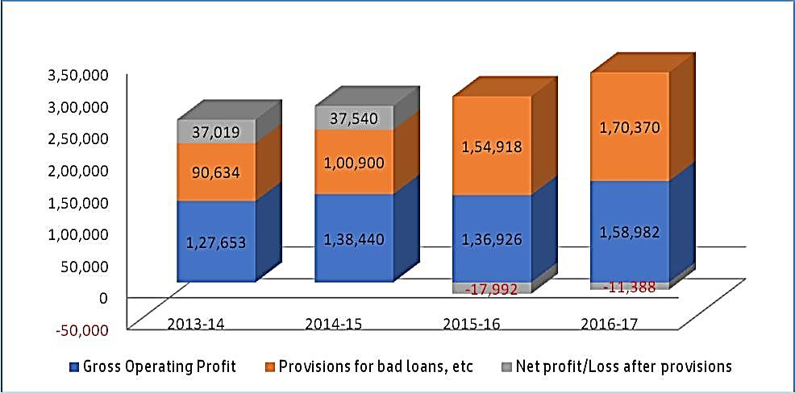

Private Sector Banks (old and new)

Rs in Crores
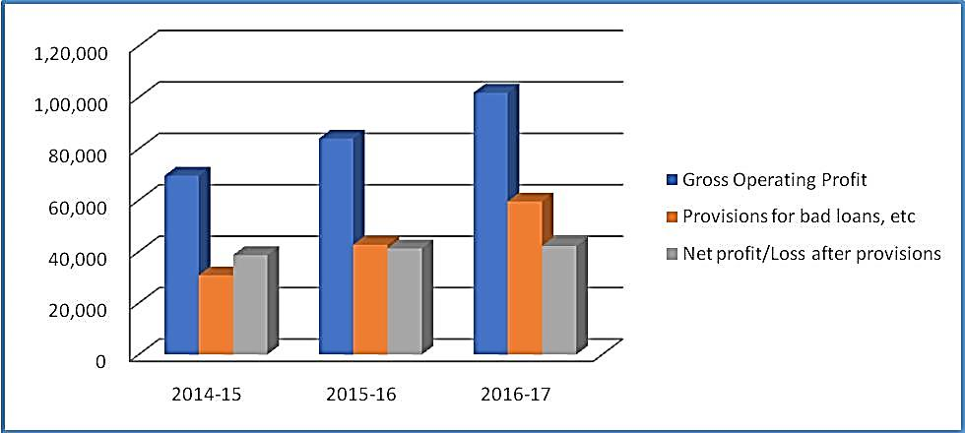

(Public Sector Banks) | Gross Operating | Provisions made for | Published
 | Profit Before | Bad Loans/NPAs | Net Profit
 | Provisions for Bad
Year
 | Loans
2008-09 | 45,494 | 11,121 | 34,373
2009-10 | 57,293 | 18,036 | 39,257
2010-11 | 74,731 | 29,830 | 44,901
2011-12 | 87,691 | 38,177 | 49,514
2012-13 | 93,684 | 43,102 | 50,582
2013-14 | 1,27,653 | 90,634 | 37,019
2014-15 | 1,38,440 | 1,00,900 | 37,540
2015-16 | 1,36,926 | 1,54,918 | -17992
2016-17 | 1,58,982 | 1,70,370 | -11,388
FROM 2008-09 TO 2016-17 | 9,20,894 | 6,57,088 | 2,63,806

Where have the profits gone?

It can be observed from the above Table that in the last 10 years, while Banks have been consistently earning Operating Profits year after year, nearly 70% of hard-earnedprofits have evaporated due to provisions for bad loans and NPAs. The net profits are getting reduced only due to huge provisions for bad loans and not due to any reasons attributable to the employees and officers of the Banks.

Net Profit of banks cannot be linked to the performance of employees and officers since it is directly sensitive to the decisions of policy makers and top managements.

Increasing Bad Loans– Are employees/officers responsible?

\

It is well-known that Provisions for bad loans are increasing because bad loans and NPAs are increasing every year as per our information. Now the bad loan structure and figures are well known to the public and no need to figure out again to magnify the real reason behind this bad loan.

Can IBA say that ordinary employees and officers of the Banks are responsible for these huge bad loans in the Banks? Can the officers be victimised with lesser wage revision because of this huge NPA?

In addition, bank employees and officers are compelled to undertake so much of non-banking business including Aadhar enrolment work and all the burden of doing various Government schemes have fallen on the shoulders of the bank employees and officers.

Everyone is aware of the increasing stress under which bank staff are working in the Bank Branches and adding salt to the wound, the approach of IBA to ignore the Charter of Demands, while discussing wage-revision is unfair and unacceptable.

- Work Life Balance in Banking Sector:

We have been subjected to enormous stress due to ever increasing workload, inadequate staff, and continuous pressure from multifarious controllers, over-ambitious targets, misplaced business priorities, extended working hours et al. This has taken a heavy toll on the efficiency level and is the root cause of frustration and anxiety disorder resulting in depression, helplessness and life-style diseases viz Diabetes, High BP and Cardiac problems etc. Officers are constantly receiving SMS and instructions over WhatsApp messages even at odd hours. This has adversely affected their social and family life. Banking system has forgotten that an officer is just not an employee of the Bank, but also a spouse/son/father/mother and an integral part of society. This situation has become intolerable as we find officers are virtually chained to their official duties and have no respite, even while at home.

Work-Life-Balance is the need of the hour. Many top global companies are addressing this sensitive issue through various measures. However, the ground reality almost in every institution is that majority of the officers are stressed and do not have a work-life balance, which is attributed especially to the instructions received through SMS and WhatsApp, inadequate staff strength and high handedness of superiors in certain cases.

We demand IBA to take necessary steps to ensure the Work-Life Balance of Bank Officers

- Pension Related Issue:

Retirees of the banking Industry are worst hit. Their basic pay is frozen on the date of superannuation, and it is never revised in subsequent Bi Partite settlement. Worst kind of discrimination is prevailing amongst different group of retirees in the matter of payment of Dearness Allowance. Pension on Special Grade Pay is denied. Family Pension to the spouse of the deceased employees is too meagre to lead a minimum level of dignified life. Although Bank Pension Regulation is framed on the pattern of RBI/ Central Govt Pension Scheme, no steps have been taken to remove the discrimination. A section of SBI pensioners are denied pension @50% of Basic Pay. These issues were noted in the Joint note dated 25/05/2015 signed by all parties in the settlement but no forward moving steps have been taken so far to address the issue.

- Issue of Mis-selling of Third party products:

Presently every bank is pressurising its employees for cross selling of such products which are not owned by them. Employees are being rewarded in the form of commission/ incentive. Despite instructions from DFS, Banks are likely to circumvent the statutory restriction, under the Banking Regulation Act, 1949 and continue to pressurise employees to focus only on cross selling for individual gains. Besides the above, employees of all categories of the Banks are also being rewarded with one or two foreign tours every year in the name of ‘educational tours’ for their performance in cross selling of insurance and mutual fund products, the cost of which is entirely borne by the concerned Insurance/ Mutual Fund Company. In this context, we convey our sincere thanks to Department of Financial Services for issuing suitable guidelines to SBI and other PSBs vide their communication dated 10th September, 2018, not to pay commission on cross-selling business to the employees of the Bank as they are full time employees and are paid fixed salaries. Unfortunately, individual Bank Management is clarifying their action of distribution of commission as incentive for personal gain of employees/ officers of all tiers due to which verbal unethical instructions are being issued culminating to mis-selling of the products. We reiterate that we have no issue against cross-selling per se; we are only concerned about the way it is being forced on bankers resulting in unethical practices at the cost of core business.

- Scrapping of NPS and switching over to Defined Pension Scheme:

NPS is not defined pension and hence uncertain. In existing Pension scheme in Banking Industry, Pension is pre determined. But in NPS it depends on the capacity of the fund to generate return causing frustration amongst the post April 2010 recruitee. In NPS, an employee has to indicate his risk appetite at the time of joining in the fund. There are three type of risk profile to choose from viz. 1) Low risk, 2) Medium Risk 3) High Risk. But as no switching is allowed, and the performance of the fund may vary depending upon risk pattern indicated at the time of joining, the market behaviour will determine the Pension to be received by an employee. Further, the contribution is made @10 % of Basic Pay + DA of the concerned employee leading to a huge accumulation of fund. But the rate of return on any established fund sometime shows negative return over a time horizon leading to apprehension that at the time of retirement the corpus fund may not be sufficient to generate a minimum pension benefit befitting the living standard at that particular time. Removal of uncertainty is pre condition for ensuring whole hearted alignment with job and for this Superannuation benefit should be defined.

- Serious HR issues in Catholic Syrian Bank and IDBI Bank:

The new MD&CEO of Catholic Syrian Bank had assumed charge during November 2016. Since then he has committed gross violations of human rights in CSB, he has summarily dismissed officers without complying with the due process. Several sincere and honest officers have been sent on cessation of service, denying them pension and their retirement benefits. The management has unilaterally withdrawn existing legitimate employee/officers benefits using transfer is being used as a tool to harass the employees (even pregnant women were not spared) and disrupted their work life balance to such an extent that many were forced to submit their resignations. MD & CEO has threatened to finish off all trade unions and towards this he plans to dismiss the General Secretary of the Officers’ Association.

Issues in IDBI Bank-

Following the 5 days successful strike observed by IDBIBOA (affiliated to AIBOC) from 6th August, 2018 to 10th August, 2018, the office bearers are being transferred vindictively to far off places. Request transfers of members who have participated in the said strike are being denied also. Arrears of Xth Bi-partite are also pending for payment at the Bank. Increments for passing JAIIB/ CAIIB which were withheld by the bank unilaterally, though restored, are not paid retrospectively. Officers who had joined under defined pension scheme are forcefully shifted to New Pension Scheme.

- Merger/ amalgamation of RRBs, Parity of Pension and other allowances with PSBs Stoppage of merger/ amalgamation among RRBs
RRBs were conceived as decentralised Banking set up with a purpose to cater to the Banking needs of small farmers and persons of small means. Number of RRBs had been reduced to 56 from 196 without any perceptible improvement in their financial and functional aspect. Rather, RRBs are replicating the commercial Banks deviating from the purpose for which they were established. The mindless process of merger/ amalgamation of RRBs announced by Govt. of India need to be stopped.

Parity with public sector banks in pension and other benefits available in RRBs

Despite of award of National Industrial Tribunal and judgements of Hon’ble Supreme Court, parity with Public Sector Banks in respect of Pension & other benefits is yet to be extended by Govt. of India in RRBs. The judgement of Hon’ble Supreme Court in regard to extension of Pension in RRBs is not being properly implemented. Repeated representation of Govt. of India / NABARD could not evoke any positive response.

- Amalgamation in banking sector:

We strongly oppose and condemn the Government’s move to merge/ amalgamate the three Public Sector Banks - Bank of Baroda, Dena Bank & Vijaya Bank to a single entity.

The core problem faced by the Indian banking industry is the enormous pile up of NPAs over Rs. 10 lakh crore that have accumulated on account of faulty lending practices and the absence of any strategy to recover the amounts from corporate houses. The much publicized Insolvency and Bankruptcy Code (IBC) process has also not succeeded in recovering NPAs and has rather resulted in substantial haircuts for the banks. The absence of strong penal action against the corporate fraudsters like Vijaya Mallya, Nirav Modi, Mehul Choksey etc. reflect the lack of political will on the part of the Union government.

In this backdrop, the announced merger/ amalgamation of three public sector banks is nothing but a diversion away from the core issue of NPA recovery. Mergers cannot resolve or clean up the balance sheets; rather the NPAs of the three merged entities would simply add it up. The improvement in certain ratios, if any, would amount to mere financial engineering, without resolving the actual problems.

The organisational disruption through the merger would relegate every other activity to the backstage. Banks involved may have to do fire-fighting for next few years, adversely affecting other banking activities

in order to integrate people, processes and procedures. The recent experience of merger of the SBI associates with the SBI has already led to humongous losses and NPA accumulation in the last financial year. Yet, the Finance Ministry seems to have learnt no lesson from it.

In a recent note to the parliamentary Estimates Committee on Bank NPAs, former RBI Governor Dr.

Raghuram Rajan had termed bank mergers as a “non-solution” to the NPA problem.

Hence, taking into consideration the overall welfare of the people of our country and towards building a healthy economic growth, we demand to halt all bank mergers immediately.

(10) Attack and Assault on Bankers:

With deep consternation, we wish to bring to attention of all, the increasing trend of vitriolic attacks by some politicians and a few elected representatives on Banks and Bank employees, thus fomenting public wrath. In this context, we had sent a communiqué to the Chairman, IBA vide our letter no. AIBOC/2018/77 dated 05.10.2018, where we have demanded to take up the matter with Home/ Finance Ministry for redressal. We place on record our sincere appreciation to the Department of Financial Services, Government of India, for having taken due cognizance of the vulnerability of bank employees and for having issued appropriate advisory. However, we are deeply anguished to note the continued attack on the banks and bankers in many parts of the country remains unabated. Elected representatives have been making derogatory remarks on the officers and have even aired views that officers will be arrested if recovery steps are pursued. In fact, we have come across press statements of elected Representatives threatening action against bankers.

You are aware that officers and staff are bound by the recovery policies framed by each bank. It is a known fact that operating staff have no discretion or freedom to stop recovery measures, unless specific directions are issued to them. If there is any lapse on the part of officers for adhering to extant norms on following up measures, officers are subjected to disciplinary procedure for lapses. The recovery of loans is deferred only in case of natural calamity, upon proclamation by the respective State Government.

It is expected that Governments, elected representatives and persons in responsible positions should initiate appropriate steps to declare calamity to provide relief to farmers and the borrowers. Instead of this, an environment of fear psychosis is being created, threatening the bankers and preventing them from performing their duties and making them vulnerable to attacks. At this critical phase which the public sector banks are traversing, the same is likely to dent the culture of repayment and the very institution of banking, in addition to causing anxiety and uncertainty in banking fraternity. While we emphatically affirm that we are
ever-ready to work for the welfare of the farmers, who form the backbone of this country, Governments should come forward with possible and plausible measures in keeping with the laid down norms.

We appeal to take up the matter with the Finance/Home Ministry to issue appropriate instructions immediately to the State Governments exhorting swift and stringent action against any attempt of threats to banking fraternity and urging government machinery to ensure adherence to the established way of helping the famers and the borrowers by providing relief through restructuring/rescheduling of loans within the norms framed by the Reserve Bank of India.

(11) Unilateral reduction in Medical benefits of officers:

Regarding medical benefits our demand was that to enable us to arrive at the premium enhancement, UIIC should be prevailed upon to provide the details area wise availment of facility i.e. Metro, Urban, Semi Urban and Rural. We are not agreeable to any reduction of bed charges for officers. We should ponder upon the fact that, before the medical insurance came into force, the eligibility of bed charges for officers was 125% higher than that of Workmen employees. Accordingly, bed charges may be worked out on that principle.

Earlier to the introduction of the Hospitalisation Scheme backed up by Insurance, A.I.I.M.S. rates were kept to consider the reimbursement. During the discussions, it was informed that State Bank of India has got tie-up arrangements with 400 hospitals and charges for treatment also capped. Combining the above documents, the rates are to be fixed, facilitating to a situation of restricting the reduction of bed charges across the Board and also other charges.

But all our suggestions were ignored and bed charges of the officers and other charges related to it have been unilaterally reduced.

(12) Steep increase in medical insurance premium:

Regarding Medical facilities for the retirees our objections were that

- The policies for serving employees and Retirees have not commenced from a common date as was suggested.

- Retirees have not given multiple options to choose from i.e. coverage of Rs 1 lakh, Rs 2 Lakh, Rs 3 lakh and Rs 4 lakh to broaden the coverage of the policy. This flexibility need to be extended for the super top up policy also.

- The premium imposed for medical treatment in respect of officer retirees is absolutely unfair, illogical and unacceptable. It appears that this pricing has been fixed in such a manner so as to drive away the retirees from the purview of the scheme. This issue requires immediate intervention and suitable initiatives to be taken for logical reduction of premium.

- Our suggestion for lesser premium rate for single beneficiary like family pensioners, etc. has been ignored.

- IBA should send communiqué to all Banks to subsidise/bear the Insurance premium of Retirees as is done for EDs/MDs of Banks as most retires are likely to face extreme difficulty in arranging funds for the renewal.

- IBA may advice member banks to give interest free loans to retirees recoverable in easy instalments for payment of premium.

Our other suggestions were that a comprehensive affordable health care policy covering the interest of bank men (both Serving & retiree) should be negotiated upon. It is also suggested that instead of annual renewal, the policy should co-terminate with the validity of wage settlement period with further provision of renewal on payment of pro rata premium post termination of policy date and delay in finalisation of future wage accord. IBA should also approach the Ministry of Finance to exempt GST on Banks health care policy being a part of staff welfare measure not strictly falling within the definition of business transaction. IBA has not addressed the issues raised by us and unilaterally implemented the revised scheme.

2. Details of Agitational Programme:
05.12.2018 | Strike Notice to IBA, RLC, Mumbai, DFS and CLC, New Delhi
07.12.2018 | Evening time demonstration at all major centres and district headquarters
10.12.2018 | Poster campaign at all branches/ offices/ Rly.stn/ Bus stand
11.12.2018 | Evening time demonstration at all major centres and district headquarters
12.12.2018 | Badge Wearing to commence and continue till the date of strike
14.12.2018 | Centralised Dharna at Delhi and submission of Memorandum to Hon’ble Finance Minister
17.12.2018 | Demonstration at all Corporate/ Head/ Zonal/ Regional offices by individual affiliates
19.12.2018 | Press Conference at all State Headquarters
20.12.2018 | Rally at evening time at all centres
21.12.2018 | STRIKE

UNQUOTE:

